SPECIAL REPORT FROM WIRED

<https://www.wired.com/story/coronavirus-covid-19-homeless/>

For Homeless People, Covid-19 Is Horror on Top of Horror

As the coronavirus spreads, unhoused people are among the most vulnerable to infection.

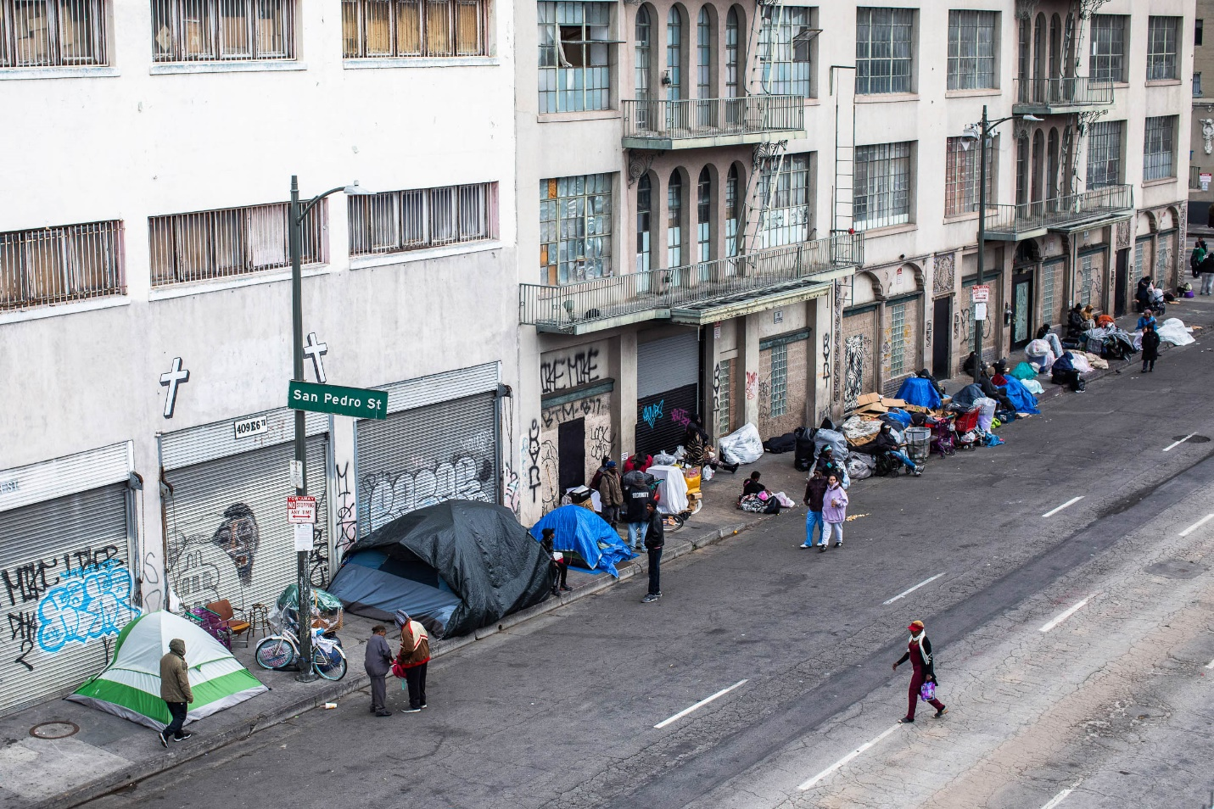

As the coronavirus outbreak continues, Los Angeles has been providing unhoused people with motorhomes and RVs, which allow them to maintain social distance. PHOTOGRAPH: APU GOMES/GETTY IMAGES

**“THERE IS NOTHING,”** a desperate poster writes, and a dozen others agree. Online communities dedicated to homelessness, like Reddit’s r/homeless, were already places to vent about unlivable living situations, but as the [Covid-19](https://www.wired.com/tag/covid-19/) outbreak continues, the challenges they face have only gotten more extreme. Shelters are full, or closed, or too fraught with [coronavirus](https://www.wired.com/tag/coronavirus/) risk to consider sleeping in. They have no access to toilets, much less toilet paper. They’ve been laid off, and there’s nobody on the street so they can’t even panhandle. Common places to find shelter and a bathroom—libraries, gyms, fast food restaurants—are closed. Soup kitchens are closing, out of food, out of workers.

The forums have become literal survival guides: How to set up a safe shelter in the forest; where to find an electrical outlet; how to clean yourself with dry leaves, newspaper, and isopropyl alcohol. “For everyone else this is ‘quarantine and chill,’” Reddit user UNTGaryOaks tells WIRED. “When you're homeless there is no quarantine, or chill. Unless you're the type that is comfortable laying on the ground in public.”

Homelessness is incompatible with health. Experts like Margot Kushel, a professor of medicine at UC San Francisco who studies homelessness, have been saying so for decades, but, in the midst of the coronavirus pandemic, it's never been truer. “It’s a calamity. It’s our worst nightmare,” Kushel says. “It’s an enormous crisis superimposed on an existing crisis.” Unhoused people are already among the most sick in society, and now they’re physically incapable of following the Centers for Disease Control and Prevention’s most basic virus-fighting directive: stay home.

It’s nearly impossible for homeless people to maintain social distance. Their needs are met en masse. The CDC recommends 110 square feet per person for people housed together during the outbreak. Most homeless shelters simply don’t have that kind of space. “There has always been an increased risk of communicable diseases like tuberculosis, hepatitis A, and influenza,” Kushel says. Covid-19 is just the newest addition to the list. Some shelters are rearranging the furniture to house people farther apart, but those adjustments inevitably mean fewer beds, leaving more people outdoors. In [Las Vegas](https://www.theguardian.com/us-news/2020/mar/30/las-vegas-parking-lot-homeless-shelter), people are sleeping in parking lots, confined to white painted rectangles spaced six feet apart.

Even before the outbreak, many homeless people were left totally unsheltered. In California, where Governor Gavin Newsom [estimates](https://fortune.com/2020/03/19/homeless-coronavirus-california-gavin-newsom/) some 60,000 homeless people could end up infected with coronavirus, two thirds of the unhoused population lives outdoors, which is about twice the national average. Unsheltered people still rely on congregate settings to meet their basic needs, like food and hygiene, though the latter often goes unmet. “These mass feeding events, they have very good intentions, but they often don’t think about the public health side of things,” says Drew Capone, a water sanitation and hygiene researcher at Georgia Tech. “We saw in our research in Atlanta that most open defecation happens within 400 feet of a soup kitchen. Not a lot of hand washing goes on. They’re not opening toilets to folks.” According to a Reddit user who wished to remain anonymous, “Having nowhere to poop is the worst part.”

The conditions of homelessness would leave a healthy person vulnerable to catching a disease like Covid-19, and unhoused people tend not to be healthy. “Your first needs are finding food and a place to sleep,” Kushel says. “Healthful behaviors come next.” In addition to not being able to maintain good hygiene or a good diet, unhoused people disproportionately suffer from lung disease, heart disease, hypertension, and cancer, which are all risk factors for experiencing Covid-19’s more severe and deadly symptoms. They also tend to be older: Half are 50 years old and up. “They also age prematurely,” says Kushel. “If they’re 50, physiologically, medically, their bodies act more like they’re 70 or 80 because of the incredible challenges of being homeless.” For unsheltered people, matters tend to be even worse. According to Nan Roman, president and CEO of the National Alliance to End Homelessness, many unsheltered people—including about 80 percent of unsheltered women—suffer from a serious medical condition, poor mental health, and drug addiction all at once.

Many of the meager resources the homeless community has been relying on are now becoming unavailable. “Since the outbreak started, things have changed. We were not allowed a hot breakfast or lunch any more, only cold bagels, cold pizza, and cold PB&J sandwiches,” says Robbie, who recently spent time homeless in Polk County, Florida, and declined to give his last name. “You used to be able to come in, get a hot meal and shower and be free to leave, but now if you don't plan on staying the night, you can't come in for dinner or a shower. You get a bag lunch and are sent on your way.” Roman explains that these changes are purely a matter of logistical strain. “The shelters themselves are losing staff. Their staff are getting sick or their kids are home from school. Volunteers who provide staff overnight or food, they’re not coming,” Roman says. “They’re having a difficult time supplying food to people, and we’re starting to see some of them close.”

Robbie was able to head north to Pennsylvania and stay with grandparents to avoid further deprivation, but many do not have that option. The economic conditions of the Covid-19 outbreak are dire: As people lose their jobs, some are finding themselves on the streets, despite anti-eviction measures meant to prevent that. Quarantine is also increasing the rates of domestic violence. “The message to stay at home is the right and correct public health guidance, but creates another public health issue,” says Debbie Fox, the National Network to End Domestic Violence’s housing policy specialist. “People are left in the lack of choice. You can stay home, which is not a safe place for many survivors, or risk your health and the health of your children by going to a shelter.” Women’s shelters, like homeless shelters, are overflowing, and all the mechanisms they’d typically use to get survivors out of the shelters—like renting apartments—have stalled.

Fox and others want people who are struggling to know that they should still be asking for help, and that people are still working hard to provide it. The federal government has included funding to help homeless people (and victims of domestic violence in particular) in its Covid-19 stimulus package. Some $4 billion has been earmarked for their relief, which, though it’s less than half of the $11.5 billion the National Alliance to End Homelessness projects it will need, is still seven times their usual annual allotment. Roman expects that shelters will no longer struggle to afford food for their residents, though staffing is still likely to be a problem.

The money can also go to additional housing solutions. “The easiest way to get people hooked up to basic services is to find them housing,” says Capone. The most popular solution to this crisis is to put unhoused people up in hotels and motels, most of which have plenty of empty rooms since many people are staying at home and not traveling. States

like [California](https://abc7news.com/coronavirus-sf-to-house-homeless-vulnerable-in-hotels/6069065/) and [Texas](https://www.kut.org/post/austin-turns-hotels-and-sobering-center-house-homeless-covid-19-patients) have already begun moving the most vulnerable members of the unhoused population into hotel rooms. “In my dream, we get everyone into a hotel room tomorrow, but it’s proven to be hard to do this,” says Kushel, who helped craft California’s response to the crisis. Some hotels would rather stand empty than house homeless people. Even hotels that are willing have valid logistical concerns about staffing, particularly if they are being asked to house people who have tested positive for the virus. “I worry too about folks who have opioid use disorders being behind closed doors,” Kushel says. “You need to make sure that they have opportunities for opioid replacement therapy, and you would want to make sure that, if they were injecting drugs, you have other people around.”

Hotel rooms are far from the only solution advocates are pursuing. [Los Angeles](https://www.usatoday.com/story/travel/2020/03/30/coronavirus-crisis-rvs-motor-homes-used-quarantine-homeless/5080088002/) is providing unhoused people with motorhomes and RVs, which allow them to maintain social distance. According to Roman, some counties are opening up additional shelters to reduce their density. In Seattle, homeless people who test positive for Covid-19 are being housed together in a shelter with full-time medical staff available if anyone takes a turn for the worse. Many groups from [El Paso](https://www.elpasotimes.com/story/news/2020/04/01/coronavirus-el-paso-hand-washing-stations-for-homeless-covid-19/2925687001/) to [Atlanta](https://www.blackenterprise.com/this-atlanta-man-is-assembling-portable-hand-washing-stations-for-the-homeless/) to [Austin](https://www.kvue.com/article/news/health/coronavirus/coronavirus-austin-homeless-protection/269-b79428db-ac72-4182-9f44-ff59fc67a42b) are bringing hand washing stations and portable toilets to existing encampments. Many unsheltered people are resistant to the rules imposed by shelters (and hotel rooms), so providing them with resources where they are can be a better option than breaking up an encampment and forcing people to scatter. “People who make the decisions often don’t know much about the lifestyle of the people at the other end of society,” says David Wagner, a sociologist who studies homelessness. “So people don’t get looked after.”

The feeling of being misunderstood pervades online spaces dedicated to the unhoused community. “I wish the government would … meet us where we are and help us with our needs,” says Robbie. “They have already failed us, I believe they should look out for us while this pandemic is going on. It's a nightmare on top of a nightmare and we feel left out.” Some, like Dogdave, who is homeless in Eugene, Oregon, believe there are simple legislative oversights that would benefit many if corrected. “The current [food stamp] policy prevents recipients from purchasing hot food,” Dogdave says. “It is intended to promote the preparation of hot food at home. I do feel a basic knowledge of meal preparation is essential, but not always possible.” Particularly not in the midst of a pandemic.

Dogdave says that he and others in his community are particularly worried about being forgotten. Wagner and Kushel both urge housed people not to forget about those less fortunate than they are, even if they are currently out of sight as people isolate themselves at home. If you’re given to optimism, the level of suffering experienced by unhoused people during the pandemic could be the push people need to solve a crisis that has been untenable for decades. “The scale of this crisis is so enormous that it’s going to take federal involvement. Call your elected,” Kushel says. “And if you’re someone who employs people, like a housekeeper or a gardener, and you’re still getting paid, God, I hope you’re paying them.” If people don’t act now, and the economic crisis worsens, America’s existing unhoused people won’t be the only ones without homes to shelter in.